|  |
| --- |
| University of the West Indies Cave Hill Campus  COMP 1170  Entrepreneurship for Computer Scientists  Group Assignment |
| **Business Proposal and Report**  *Down De’ Gap* |
|  |
| *Semester:* Semester 1 2022/2023  *Course Name:* Entrepreneurship for Computer Scientists  *Course Code:* COMP1170  *Lecturer:* Mr. Clinton Gittens  *Candidate Names and Numbers:*  Caleb Ellis: 400014224  Joshua Layne: 400014516  Azari Gittens: 400010840  Shania Walcott:400015697  Chavez Bobb: 400011791  Jaedyn Cupid: 400014745 |

**Table of Contents**

Business Introduction 3

Feasibility Analysis 4

Strength of Business Idea: 4

Industry-Related Issues: 4

Target Market and Customer-Related Issues: 4

Financial Issues: 5

Down De’ Gap Consumer Survey 5

Survey Results 7

Business Model 18

Barringer/Ireland Business Model Template 18

Industry and Competition Analysis 22

The Founding Team 27

Roles 27

Plan to Mitigate Liability of Newness 27

Justification 27

Short Skills Profile 28

Ethical & Legal Issues 29

Business Licensing 30

Funding/Financing Strategy 31

Marketing Strategy 32

Product: 32

Price: 32

Promotion: 32

Place: 33

Appendix 34

Partners’ Agreement 34

# Business Introduction

Down De Gap is a food directory and delivery service that hosts the menus and prices of local cuisine from small to medium sized food businesses around the island. Our website acts as an intermediary between the consumer and our supplier operators.

During the Covid-19 pandemic there was a significant demand for delivery services due to the many restrictions in place, and the general fear of being around others. Some businesses, including food companies such as Chefette, were able to offer varying degrees of delivery services. We recognize that the food delivery market is still in its growing stages, and we plan to capitalize on this opportunity.

We noticed, however, that small food businesses in Barbados remain behind in this trend, although the demand remains and has been steadily growing locally across all demographics and social economic backgrounds.

Large restaurant franchises may have the resources to offer direct delivery services to their consumers, however, this is not the case for most small food businesses.

Moreover, we found out that companies such as Hopscotch, partner with the big players, such as Subway, Burger King, etc. Unfortunately for them they do not realize the untapped market from the smaller groups. Hence, our business will start on focusing on the smaller food businesses. The issue of the varied menus and different locations that is not easily visible to the general public will be easily addressed by our website which will host and allow customers to scan our directory and pull up the menus and food options available for delivery.

# Feasibility Analysis

## Strength of Business Idea:

With the rise of people not only wanting accessibility and convenience of delivery, In which persons who genuinely want to search and taste local cuisine without having to break the bank. Our Business Down De Gap, uses a website that allows potential stakeholders to host their menus and location. Moreover, they can opt to have a delivery option where their food can be delivered to customers. We believe that people will want to use this amazing service as it benefits not only customers who are looking for something to eat but also small food business owners who can get their name out there and share their food with people who are interested in it. This is the peak opportunity to execute our idea as we are definitely not too late. The website is very user friendly where both old and young can navigate and make purchases with ease.

## Industry-Related Issues:

We have few competitors within the market already and although we believe that our Business Idea is enticing, that doesn’t stop our Competitors with bigger capital to implement fascinating features or “improve” their site’s. However, we still have a lot of wiggle room to work with especially since the market is still somewhat new locally. Furthermore, after some research people are more likely to order from smaller local businesses rather than the larger franchises and since Down De Gap is also a local directory/map of smaller locations it attracts customers who may want to explore, even better since covid restrictions lessened.

## Target Market and Customer-Related Issues:

Our business targets young individuals who not only have money to spend but are looking to explore or get something to eat, nevertheless we are not limiting ourselves towards that specific niche since older people will be able to use our website to order delivery along with being able to search for food business that are closer to them. Although marketing is going to be a bit slow due to funding, advertising using social media will cut on costs and also give us a small demographic to establish ourselves. Better yet through our economic prices, individuals will have no problem subscribing for our services no matter their circumstances, creating wide potential for growth within the public.

## 

## Financial Issues:

Our initial capital investment is (insert amount), since it is a partnership it will be easier to set-up. Moreover, with our business Idea finding positive income comes simpler and maintaining our site, etc. won’t be much of a problem . Down De Gap will have a couple of ways to make and sustain its revenue and it should be more than enough to create a significant profit. Using a subscription service for both customers and potential partners, unintrusive advertisements on our site and taking 10% cut on deliveries are just a couple of ways to create positive cash flow for us. renting or buying our sites domain would be relatively cheap however, keeping and maintaining the servers for our web-site is going to be the most expensive thing we worry about, still, we have already made plans for how we would be able to fund our service and giving a percentage amount every 3 months we would be able to break even within 1-2 years of coming into the market space.

## Down De’ Gap Consumer Survey

1.   What is your gender?

[] Male

[] Female

[] Nonbinary

[] Prefer not to say

2.   How old are you?

[] under 18

[] 18-15

[] 26-35

[] 36-45

[] 60+

3.   How often do you eat fast food?

[] Not at all

[] 1-2 times a week

[] 3-5 times a week

[] 6-7 times a week

[] More than 7 times a week

4.Which restaurants(s) do you normally order food from?

[] Burger King

[] Chefette

[] KFC

[] Subway

[] Chicken Barn

[] other ________________________

5.How likely are you to order from other location not listed above?

Very unlikely  1      2      3      4      5   Very likely

6.How aware are you of small food businesses within your community?

Very unaware  1      2      3      4      5   Very aware

7. How often do you purchase food from small food businesses within your community?

Very little  1      2      3      4      5   Very often

8. How aware are you of the food items and prices listed at these businesses?

Very unaware  1      2      3      4      5   Very aware

9. How willing are you to purchase food from businesses that you are unaware of if you were provided with their location, menu, and further details?

Very reluctant  1      2      3      4      5   Very willing

10. How important is being able to research a new restaurant before purchasing food to you?

Little to no importance  1      2      3      4      5   Very important

11. What information do you value the most when considering a new restaurant?

# 

## Survey Results

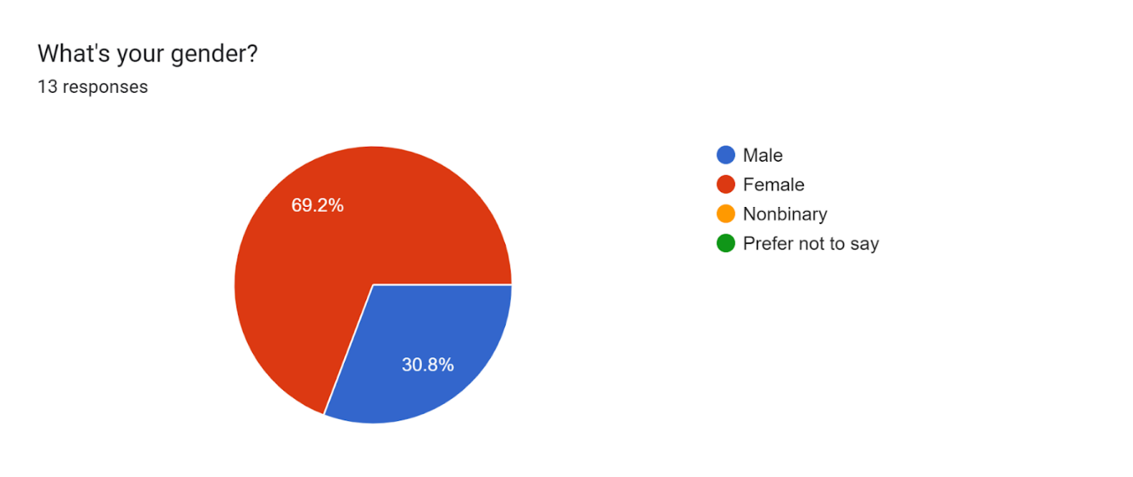

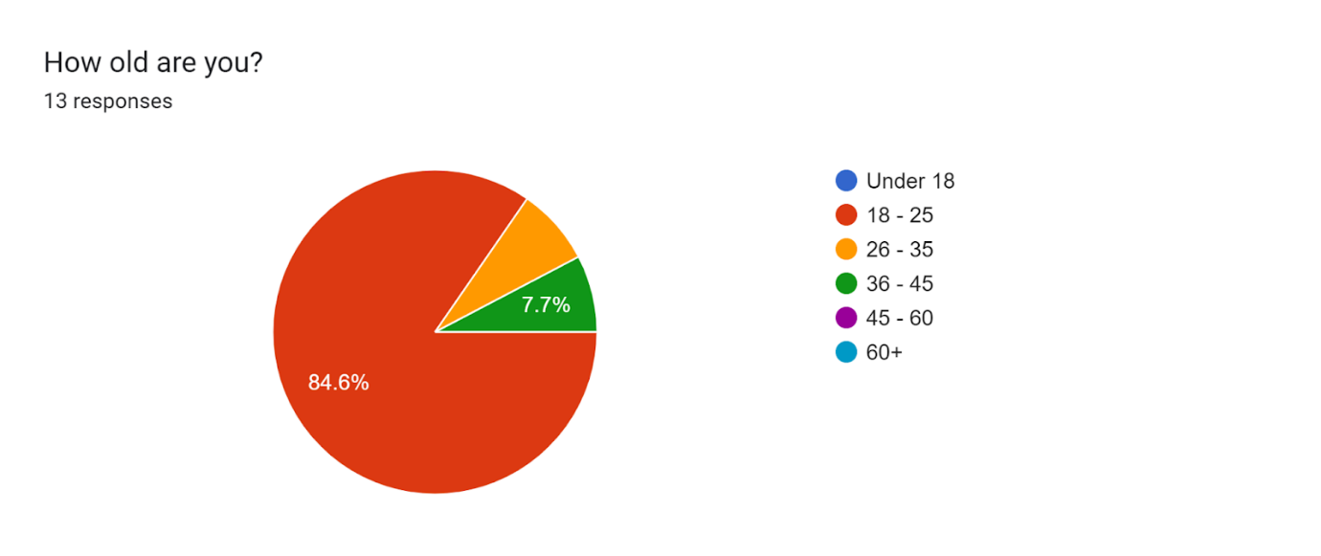

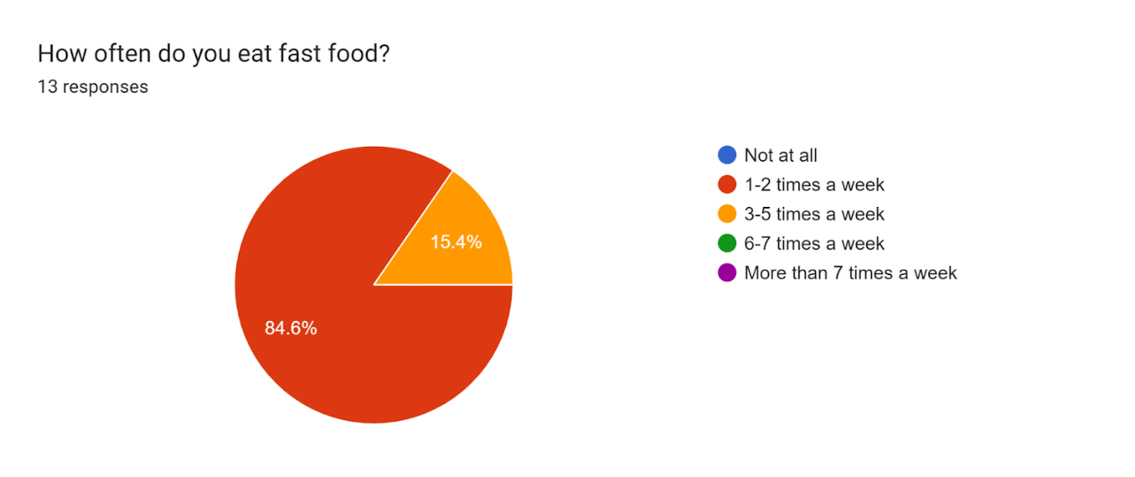

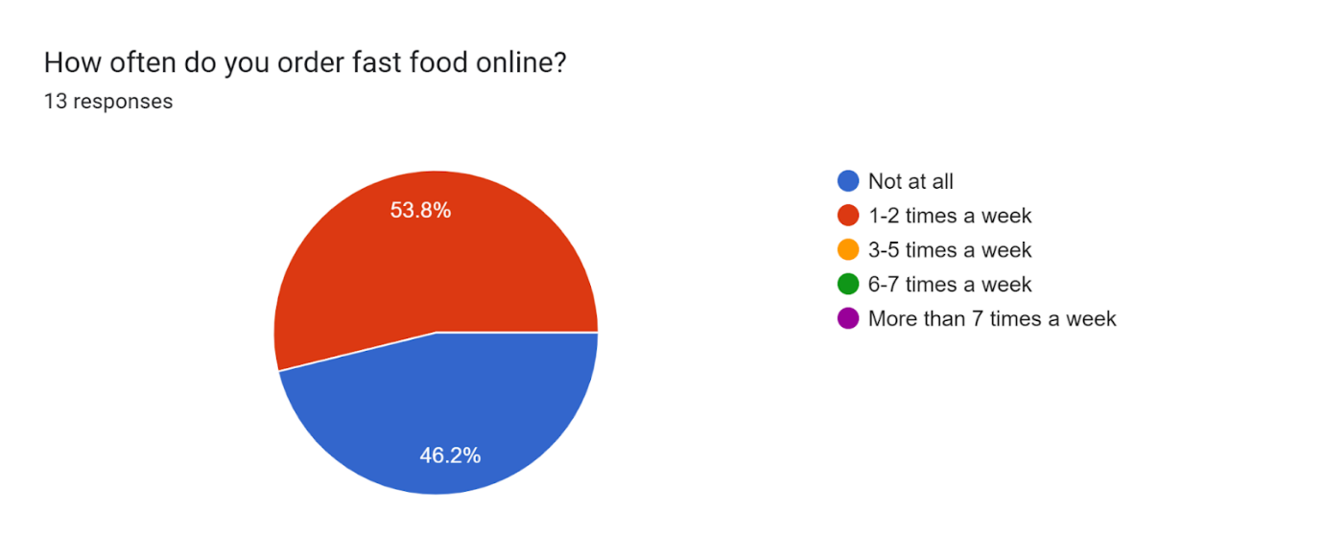

Forms response chart. Question title: Which restaurant(s) do you normally order food from?
. Number of responses: 13 responses.

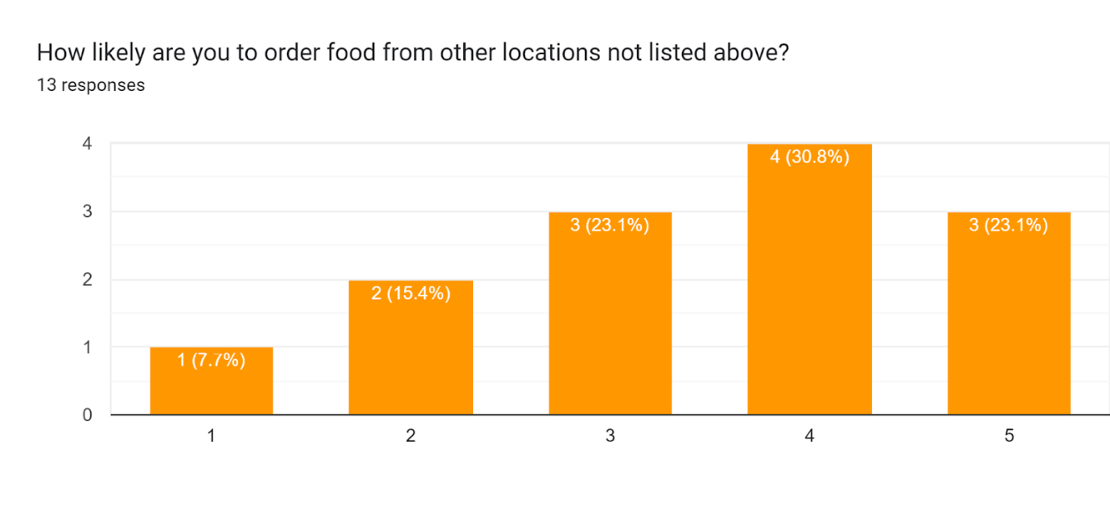

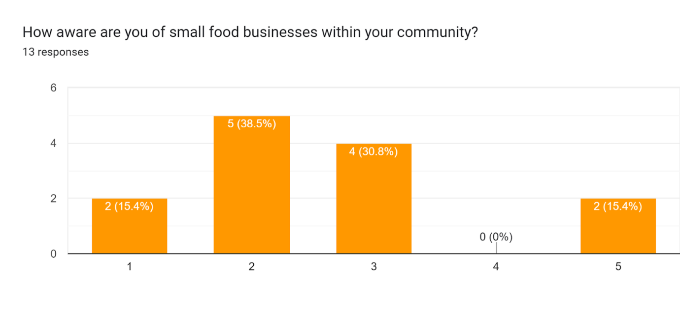

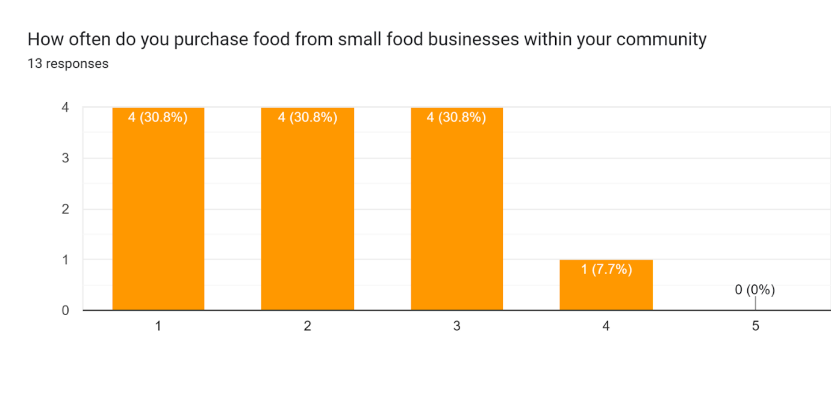

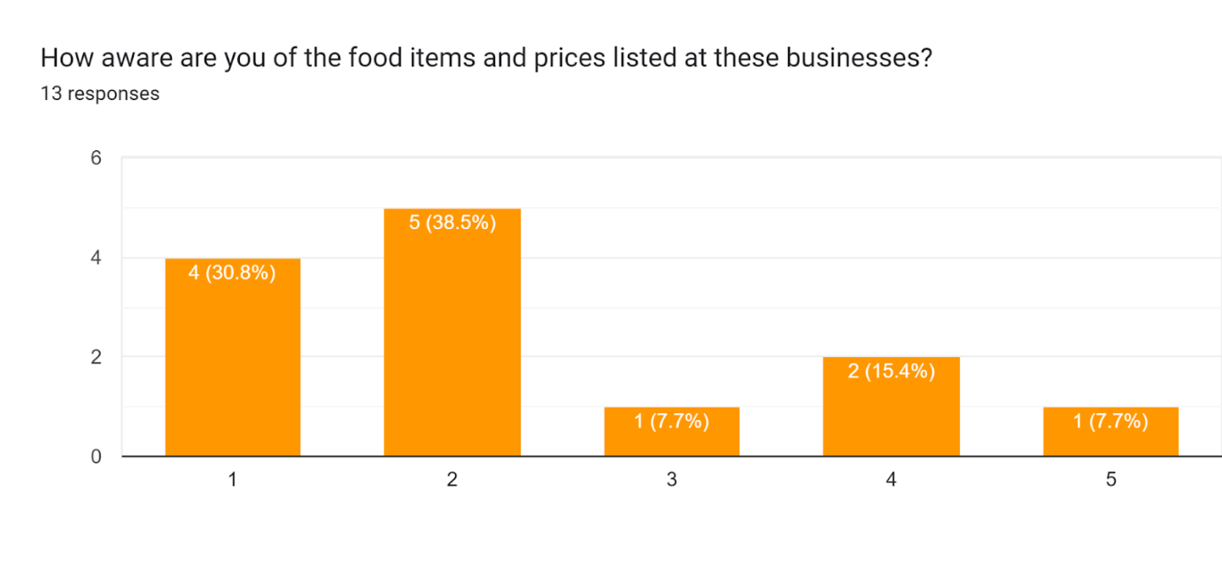

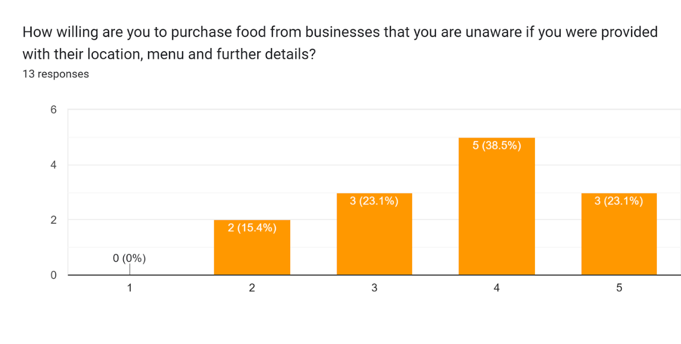

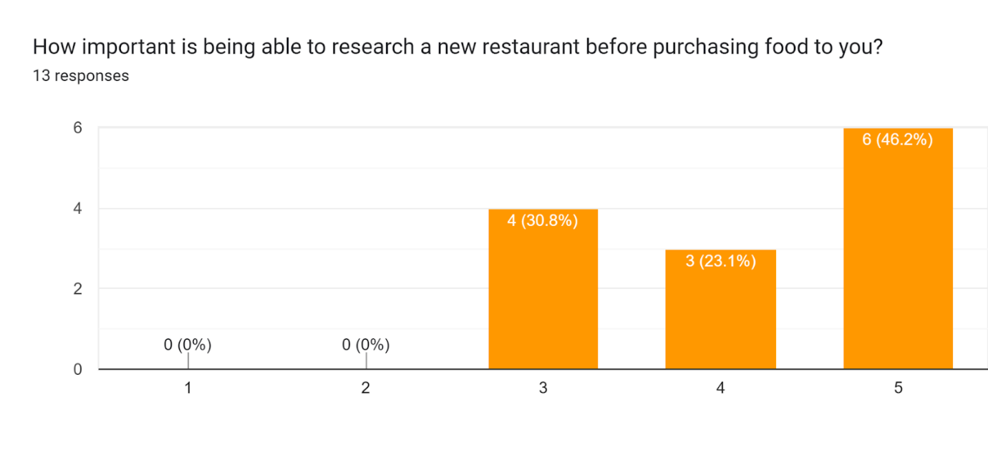

What information do you value the most when considering a new restaurant?

* Reviews
* Price and menu options
* Their menu options and prices
* Price and quality
* Feedback from customers about the taste, price, quantity, if delivery is offered, a good delivery service
* Location, price, menu
* Price and quality of food
* Cleanliness of environment and quality of food

|  |  |  |  |  |
| --- | --- | --- | --- | --- |
| **Part 1: Strength of Business Idea** | | | | |
|  | |  |  |  |
|  | **Low Potential (-1)** | **Moderate Potential (0)** | **High Potential (+1)** | **Score** |
| 1. Extent to which the idea | Weak | Moderate | Strong | 1 |
| a) Takes advantage of an environmental trend |
| b) Solves a problem |
| c) Addresses an unfilled gap in the marketplace |
| 2. Timeliness of entry to market | Not Timely | Moderately timely | Very Timely | 1 |
| 3. Extent to which the idea "adds value" for its buyer or end user | Low | Medium | High | 1 |
| 4. Extent to which the customer is satisfied from competing products | Very satisfied | Moderately satisfied | Ambivalent | 0 |
| 5. Degree to which the idea requires customers to change their basic practices or  behaviours | Substantial | Moderate changes | Small to no changes | 1 |
|

|  |  |  |  |  |
| --- | --- | --- | --- | --- |
| **Part 2: Industry-Related Issues** | | | | |
|  | |  |  |  |
|  | **Low Potential (-1)** | **Moderate Potential (0)** | **High Potential (+1)** | **Score** |
| 1. Number of Competitors | Many | Few | None | 0 |
| 2. Stage of Industry Life cycle | Maturity Phase | Growth Phase | Emergence phase | 1 |
| 3. Growth rate of Industry | Little or no growth | Moderate growth | Strong growth | 1 |
| 4. Importance of Industry's products and/or services to customers | "Ambivalent" | "Would like to have" | "Must have" | 0 |
| 5. Industry operating margins | Low | Moderate | High | 0 |

|  |  |  |  |  |
| --- | --- | --- | --- | --- |
| **Part 3: Target Market and Customer-Related Issues** | | | | |
|  | |  |  |  |
|  | **Low Potential (-1)** | **Moderate Potential (0)** | **High Potential (+1)** | **Score** |
| 1. Identification of target market for the proposed new venture | Difficult to identify | May be able to identify | Identified | 1 |
| 2. Ability to create "barriers to entry" for potential competitors | Unable to create | May or unable to create | Can create | 1 |
| 3. Purchasing power of customers | Low | Moderate | High | 1 |
| 4. Ease of making customers aware of the new product or service | Low | Moderate | High | 0 |
| 5. Growth potential of target market | Low | Moderate | High | 1 |

|  |  |  |  |  |
| --- | --- | --- | --- | --- |
| **Part 4: Founder - (or Founders) Related Issues** | | | | |
|  | |  |  |  |
|  | **Low Potential (-1)** | **Moderate Potential (0)** | **High Potential (+1)** | **Score** |
| 1. Founder's or founders' experience in the industry | No experience | Moderate experience | Experienced | 0 |
| 2. Founder's or founders' skills as they relate to the proposed new venture's product  or service | No skills | Moderate skills | Skilled | 1 |
|
| 3. Extent of the founder's or founders' professional and social networks in the relevant  Industry | None | Moderate | Extensive | 1 |
|
| 4. Extent to which the proposed new venture meets the founder's or founders' personal  goals and aspirations | Weak | Moderate | Strong | 0 |
|
| 5. Likelihood that a team can be put together to launch and grow the new venture | Unlikely | Moderately Likely | Very likely | 0 |

|  |  |  |  |  |
| --- | --- | --- | --- | --- |
| **Part 5: Financial Issues** | | | | |
|  | |  |  |  |
|  | **Low Potential (-1)** | **Moderate Potential (0)** | **High Potential (+1)** | **Score** |
| 1. Initial capital investment | High | Moderate | Low | 1 |
| 2. Number of revenue drivers (ways in which the company makes money) | One | Two to Three | More than three | 0 |
| 3. Time to break even | 2+ Years | 1-2 Years | 1 < year | -1 |
| 4. Financial performance of similar businesses | Weak | Modest | Strong | 1 |
| 5. Ability to fund initial product (or service) development and/or initial start-up expenses form personal funds or via bootstrapping | Low | Moderate | High | 1 |
|

|  |  |  |
| --- | --- | --- |
| **Overall Potential** | | |
| **Score (-5 to +5)** | **Overall Potential of the Business Idea**  **Based on Each Part** | **Suggestions for Improving the Potential** |
|
| Part 1: | High Potential |  |
| Strength of Business Idea |
| Part 2: | Moderate Potential |  |
| Industry-Related Issues |
| Part 3: | High Potential |  |
| Target Market and Customer  Related Issues |
|
| Part 4: | Moderate Potential |  |
| Founder(s) Related Issues |
| Part 5: | High Potential | Use a Courier Service instead of us buying cars or hiring people with vehicles |
| Financial Issues |
| Overall Assessment | 3 |  |

# Business Model

## Barringer/Ireland Business Model Template

|  |  |
| --- | --- |
| **Core Strategy** | |
| **Business mission**  Our mission is to connect you, the user, with our network of small restaurants all over the island to deliver affordable, home cooked food from people like you in your community, to the comfort of your home. | **Basis of Differentiation**   * Small business oriented * Larger selection than our competitors * Hiring free-lance drivers to do deliveries |
| **Target market**  Our company plans to deliver our service to everyone who just wants a bite to eat but more specifically to consumers who crave or want home cooked meals instead of fast food. | **Product/Market scope**   * Delivering food for small food business only * Giving people a larger variety of food options to choose from * Expanding our scope and having partnerships with larger food companies in the next 3-5 years. |

**Resources**

|  |  |
| --- | --- |
| **Core Competencies** | **Key Assets** |
| * Our primary focus on small business * User Friendly website * Delivery time | * Our use of free-lance drivers * Our partnership with small food businesses |

**Finance**

|  |
| --- |
| **Revenue Stream** |
| * Income from our delivery service * Income from partnerships by advertising their businesses on our website |
| **Cost structure** |
| * Initially it was estimated that we would need $60k for funding, but now we realise we’d only need about 36k. This amount was put forward after taking into consideration the cost of all our expenses such as gas bills, advertisements, and workers’ wages, as well as any unexpected expenses. |
| **Financing/Funding** |
| * Our will be funded using our own personal finances * We will also be utilising the bootstrapping method of funding to cut on cost by hiring people who own their own vehicles * We would make use of the radio station in the country, as well as make use of social media platforms as means of advertising our business. This allows us to reach people who reside all over the island who may be interested in our service |

**Operations**

|  |  |  |
| --- | --- | --- |
| **Product or Service Production** | **Channels** | **Key Partners** |
| Down De Gap intends to connect small food businesses around Barbados to consumers by means of having a fully functional website. In addition to this, we also provide a delivery service that delivers the product to the consumers. | Our business will be used as an intermediary to connect our consumers with small food businesses. With our delivery service and website this will be made possible. We intend to advertise our business through means of social media, radio, and television advertisements. | *Small food businesses-*  As mentioned before, we plan to have partnerships with small food businesses around the island. |

# Industry and Competition Analysis

**Overview:**

This is an underdeveloped industry and an emerging market in Barbados as people are now becoming more acquainted with technology and are now more willing to order items through delivery.

This emerging industry type was chosen because it best describes the place that our company would hold within the food sale and delivery market, and it best describes the target market itself as it is still in its infancy. If we were to enter the market and succeed, we would have a first mover advantage as no other company would have the scale of networks and logistical operations that we would have developed by the time they enter the market.

**Impacts from the Five Forces:**

**Threat of Substitutes:**

There will not be a substantial threat from possible substitutes or alternatives since, as established, this is an underdeveloped industry and one with little to no major competition.

Whereas some other businesses in this field like Hopscotch are affiliated with larger food sellers and restaurants, there is no competition for those catering towards smaller operators and thus, very little substitutes for consumers. As well, for those who can cater to delivery from these smaller operators, their presence online and in the public consciousness is severely lacking as they are only known through sub-par Instagram pages and word of mouth, and as far as accessibility goes, it is not possible to make your orders directly and one must reach out to them on WhatsApp to communicate your order. In addition, the delivery fares are not available upfront, and one must manually inquire about a delivery quote directly. It is also unlikely that these delivery companies have connections with these operators where they can forward orders remotely and is likely that they act more like a manual proxy for the consumer than a delivery service.

Therefore, with a significant enough online presence and with easily accessible and transparent information about the services we provide and the operators we cover, we will be seen, by far, as the best option for consumers as our professionalism will make us more trusted by those consumers. As well, the relative speed of our operations would make us the preferred option as we could get orders to the operators in advance, as opposed to ordering in person.

**Threat of New Entrants:**

With regards to new entrants, the barriers of entry are relatively low at the moment but there is one potential barrier that could make it difficult for a new competitor who isn’t as dedicated to the same goals as we are. That is, the capital requirements. In order to run a delivery network connecting many small operators with possibly more than 30 in a 5 km radius and to maintain a substantial amount of delivery drivers to reach these places, requires a lot of capital investment upfront to expand a pre existing service to that size or to start a new service from scratch. In addition, another related possible barrier to entry for new entrants is access to distribution channels. As there will be many businesses that one will have to contact and arrange delivery arrangements in order to have significant enough variety for consumers to choose from, it would be difficult to create this network of operators relatively quickly or quick enough to match the coverage we would have established by then.

However, if they were to have the means of replicating our network, to counteract this, we will work towards having exclusive delivery dealing contracts with most of our suppliers in exchange for increased targeted promotion of their business to nearby persons and a greater portion of delivery fares. This will ensure that the networks that we build with these small operators become almost impossible to penetrate as the operators themselves will be the first point of rejection for any competitor looking to enter the market, thereby creating a barrier of entry.

**Rivalry among Existing Firms:**

At the moment, there is very little direct rivalry and most of our rivalry is in indirect competition. As there are no other major players involved in this target market, focusing on smaller operators and home grown businesses, once successful, we will likely be a market leader on the outset with little to no threat of those competitors deciding to enter our market.

In terms of difference between products, We believe there is more than enough difference between what we offer and what the other competition offers. As establish before, whereas we focus on smaller food operators, most of our competitors either don’t have such a focus on this clientele, or aren’t interesting in having such a focus where many of our minor but more direct competitors act more as couriers in general than food delivery and our major but indirect competitors are more focused on larger restaurants and are unlikely to shift their focus in the near future.

Thereby this industry is likely not to grow as fast as others due to the high upfront capital requirements needed to network all of these restaurants but our fixed costs of operation will likely be higher, meaning our rates may be cheaper than our competitors in order to attract consumers.

**Bargaining by Suppliers:**

With regards to possible bargaining by suppliers, our business model also avoids the possibility of our business being held hostage by the operators we service by giving them full control of their pricing but still charging our own delivery fee.

Thus, there would be no incentive for the operators to challenge us since we will be largely responsible for their nationwide presence, their inability to manage deliveries themselves and given the lack of readily available substitutes, they may likely lose out on business if they decide to bargain against us. As well, we can also choose to publicise certain businesses over others if they intend on complicating our corporate relationship by bargaining, thereby potentially damaging their business in the process. In addition, since none of these businesses likely have the means to deliver their meals large scale and nationwide, forward integration seems unlikely.

Therefore, our suppliers and operators would have more to lose by bargaining against us than by not.

**Bargaining by Buyers:**

As a service, our company doesn’t necessarily have buyers like a product would but more consumers who would use the service. There will be a large range of users that can potentially use this service so there wouldn't be much concentration with regards to buyers. There is very little to no threat of backwards integration as the service we provide isn’t procured by another company as components and we are unlikely to enter the food preparation business ourselves. But we will still aim to keep our delivery fares low and competitive.

A graphical representation of our competition analysis for our direct local competitors is:

|  |  |  |  |  |
| --- | --- | --- | --- | --- |
|  | Down-de-Gap | Hopscotch | Chirp Barbados | Doordash Delivery Express |
| Pricing | Flat region based and progressive distance based (+1) | Progressive distance based (-1) | N/A (-1) | Progressive distance based  (-1) |
| Potential Supplier Base | Small food operation businesses (+1) | Larger restaurants  (-1) | N/A (-1) | Large and small food restaurants and parcel couriers (1) |
| Advertising and Visibility | Prominent (Planned - online and mass media) (+1) | Prominent (online only) (-0.5) | Not prominent (-1) | Not prominent (-1) |
| Online Presence | Website and social media (0) | Website and social media (0) | Instagram only (-1) | Instagram only (-1) |
| Accessibility | Online, easily accessible (0) | Online, easily accessible (0) | Not easily accessible (-1) | Not easily accessible (-1) |
| Score | 3 | -2.5 | -5 | -4 |

**Evaluation of Some Competitors:**

**Hopscotch:**

Hopscotch is a food delivery service founded circa 2016 dedicated to delivering food from a selection of restaurants to the user on a progressive rate. By being the only established food delivery service with a professional online and social media presence, they have become the largest online delivery service in Barbados.

However, Hopscotch largely focuses on larger firms and can have long delivery times of more than an hour, even for close-by locations. They also have relatively expensive delivery fees that can sometimes cost more than the actual food itself, especially if you have the misfortune of living in the northern or eastern regions of the country. As well, even though they are relatively well known online, they have little brand recognition in the wider public as there is little exposure in the mass media (print, radio or TV). This may prove disadvantageous to their operations as they lack that public reach.

**Doordash Delivery Express:**

Doordash Delivery Express ((not that Doordash) referred to from here on as DDE) is a local small scale courier delivery service that began operations in February 2019 and is dedicated to the delivery of all sorts of items ranging from meals to parcels to pharmaceuticals to articles of clothing. They operate primarily on WhatsApp through the operator’s telephone number and do most of their public relations and promotion on Instagram.

DDE’s mode of operation may be its largest flaw. Even though their focus is large, they act primarily as couriers in general, rather than as a food delivery company, even though it may take up a majority of their operations. This would then mean that they likely do not have relations with the restaurants they are delivering from and act as a proxy for the customer. So while they theoretically cover everyone, their orders have no priority and due to possible lack of connection with the restaurants themselves, their orders can’t be sent immediately to the restaurant and thus have the additional wait of an in-person customer.

In addition, since they operate primarily on Instagram and by direct message, they do not have a public presence and mostly would advertise by word of mouth. As well, this makes basic information about their business, how they operate, their pricing and who they cover essentially inaccessible to the public, especially the segment of the public who would be unwilling and wouldn’t bother to exert additional effort to contact them for such information.

# The Founding Team

Our business, Down De Gap, will have six founders, these being: Caleb Ellis, Joshua Layne, Azari Gittens, Shania Walcott, Chavez Bobb, and Jaedyn Cupid.

## Roles

Caleb Ellis and Joshua Layne will be simultaneously responsible for the executive leadership and webpage management of the business. Shania Walcott and Chavez Bobb will be responsible for the social media management of the business. Azari Gittens will be responsible for professional communication and Jaedyn Cupid will be responsible for data management.

## Plan to Mitigate Liability of Newness

Our group will be able to mitigate the liability of newness by first partnering with relatively well-known and reputable local restaurants. This way, we can guarantee quality products to our initial customers while working on networking with lesser-known restaurants. This will also give us a grace period to construct and implement our quality checking protocols for each restaurant, and to solve any issues with our system/mistakes that we could potentially make.

## Justification

Businesses that are started by a team are likely to have an edge compared to those started by an individual, and that certainly applies to us. Our team is heterogeneous, meaning that our abilities and experiences are diverse. We may all be studying a form of Computer Science, however, we have members that are familiar with a variety of skills, such as graphic design and videography to name a few. For these reasons, although our team has only been formed recently, we are able to mesh well together and produce exceptional results.

## 

## Short Skills Profile

|  |  |  |  |  |  |  |  |  |
| --- | --- | --- | --- | --- | --- | --- | --- | --- |
|  | Driving Experience | Executive Leadership | Professional Communication | Social Media Management | Data Management | Webpage Management | Accounting and Finance | HR/ Recruiting |
| Caleb Ellis |  | X |  |  |  | X |  |  |
| Shania Walcott | X |  |  | X |  |  |  |  |
| Joshua Layne |  | X |  |  |  | X |  |  |
| Azari Gittens | X |  | X |  |  |  |  |  |
| Chavez Bobb |  |  |  | X |  |  |  |  |
| Jaedyn Cupid |  |  |  |  | X |  |  |  |
| Gap #1 |  |  |  |  |  |  | O |  |
| Gap #2 |  |  |  |  |  |  |  | O |
| Gap #3 | O |  |  |  |  |  |  |  |

X = position filled  
O = position vacant

From the skills profile, we have identified several gaps that need to be filled in the business. Although Shania and Azari have driving experience, to accomplish the style of delivery that we wish to implement additional drivers would be necessary. We are also missing individuals that can do accounting and human resource management.

# Ethical & Legal Issues

Down De’ Gap’s code of conduct directs partners and employees on making just decisions and solving problems. The code clearly sets the ethics of the business and should be used as a guide in carrying out daily activities while at the company.

***Honesty & Integrity:*** Down De Gap and its staff are committed to maintain and uphold the highest ethical standards at all times. All staff should ensure that the business operations, applications for services, and staff recruitment, are dealt with in an open, fair, and impartial manner.

**Respect:** Staff must exhibit respect towards each other as professionals at all times. Down De Gap is fully committed to uploading internationally recognised human rights of all people. Discrimination, sexual harassment, retaliation, or intimidation of any kind is not tolerated.

**Equal Opportunity for all Employees:** Down De Gap ensures that all employees are presented with equal opportunities regardless of sex, race, colour, religion, nationality, age, disability, or any other legally protected status. This applies to all aspects of the including recruiting, hiring, training, promotion, transfer, termination, and wage and salary administration.

**Safety & Health Practices:** Down De Gap is committed to an illness and injury free working environment that is in compliance with all relevant laws and regulations that protect worker safety. Down De Gap is also committed to maintaining a productive work environment that is free from discrimination or harassment. Any form of discrimination or harassment of any kind will not be tolerated.

**Fair Competition:** Down De Gap prohibits any activity which may bound, restrain, or distort competition as well as any practices of unfair competition. Down De Gap’s policy is to comply with all applicable competition and fair-trade laws and regulations of Barbados and the region.

**Anti-Corruption:** There is no tolerance for corruption at Down De Gap. Down De Gap prohibits corrupt practices in any form, including but not limited to bribery, aids, kickbacks and other unlawful payments, in both the public and private sectors. Employees must never provide anything of value to government officials or business partners to obtain an unjust advantage.

**Confidential or Proprietary Information:** Any valuable or important information that has not been disclosed to the general public must be safeguarded. Staff is not allowed to disclose any classified information to anybody without authorization.

**Property of the Company:** Property or assets of Down De Gap are to be used only for legitimate business purposes. Misuse of property for personal use or resale is prohibited.

**Conflict of Interest:** When private interests of staff oppose or conflict with those of the company, a conflict of interest arises. Staff should avoid using any resources permitted to them to benefit themselves or any persons that they have personal or social ties to.

**Misuse of Official Position:** Official position provided to staff should not be used for personal gains or to aid persons whom they have personal or social ties to. Staff who misuse their official position are subject to disciplinary action or prosecution.

**Recording & Reporting of Information:** All records and reports of information, including financial statements and transactions must be accurate, true and a clear disclosure of facts. Records must never be misleading or artificial

## 

## Business Licensing

The business will need to be claimed and registered under CAIPO and the Registration of Business Names Act, Cap. 317. The business will also need a health certificate/ operating license provided by the Ministry of Health of Barbados.

# Funding/Financing Strategy

For this business, we initially estimated that we will need around $60k for funding, this budget had included the cost of cars as well, but since we have decided to use free-lance drivers, we no longer need that big of a budget. We have now decided that we only need about 36k. This amount was put forward after taking into consideration the cost of all our expenses, such as gas bills, advertisements, and workers’ wages, as well as any unexpected expenses that may come up. We plan on acquiring this money through personal funds. Originally, we had also planned to acquire a government grant, but we have decided that it is no longer necessary.

We will also be utilising the bootstrapping method of funding to try to cut down on cost by hiring people who own their own vehicle, we can reduce the amount of money needed. In terms of advertising, we would make use of the radio station in the country, as well as making use of social media platforms as means of promoting our business. This allows us to reach people who reside all over the island who may potentially be interested in our service.

We have decided that using these strategies would be the most efficient for funding since they allow us to cut costs and to avoid having to repay any loans, as well as interest. With each of our personal savings, we are certain that we will be able to successfully fund our business.

# 

# Marketing Strategy

Down De’ Gap’s target market primarily includes tourists looking to experience local cuisine and young individuals, from the Gen Z and Millennial age groups, but also includes parents of children seeking for convenient food deliveries. Down De Gap establishes a unique position in the market as we aim to service tourists and promote smaller food businesses as compared to other competitors in the market such as Hopscotch. Down De Gap plans for its brand to be recognized for its quick, reliable and customer friendly service. “We go down de gap, so you don't have to!”

## Product:

Down De Gap’s main services include promoting, advertising, and recommending food businesses and delivering food and related items to clients/consumers. One problem the company will experience is obtaining market share and differentiating its service from competitors. Industry giants like Hopscotch leave little room to establish a stable consumer base as people are more likely to trust and use a familiar name than to take chances on unknown startups. In addition to offering discounts with consistent use of the service, we aim to provide a more social media friendly interface where users are able to see client reviews, recommendation and trending restaurants and dishes. This aims to attract customers and encourage them to continue to use our service and through reference accounts we aim to build trust and brand loyalty by targeting customer satisfaction.

## Price:

To garner interest and allow the company to compete in the market, Down De Gap intends to charge modestly below market value but increase pricing as our consumer base increases. This accompanies the risk of being unable to “break even” or make a profit in the early stages of the business and there is no guarantee that lowering pricing will result in increased traffic and sales. During this time, to compensate for the potential losses incurred, we intend to provide in-depth, helpful information to users, create and be active in communities and utilise reference accounts to firmly establish trust and customer loyalty. Cost-based pricing will be used to fairly charge for distance travelled and time taken while also reducing the cost where wait times were unreasonable.

## Promotion:

The business will be promoted primarily via low-cost strategies like social media and guerilla marketing.

Social media will be used by creating and frequently posting to official business accounts established on Twitter, Facebook, and Instagram. Any deals, specials and discounts will be actively disclosed to followers and the company will eagerly interact with followers and aim to answer most questions while also paying close attention to and utilising trends to create a vibrant community with high levels of engagement.

Guerilla Marketing will be used to ensure that we stand out and gain attention so that we are able to advertise the company for relatively low costs. Partners will traverse while wearing a company shirt and actively engage with the public in order to hand out business cards and spread general information on the business. We aim to hand out coupon codes which discount your first purchase to entice potential consumers to use our service while offering temporary additional benefits to them. Using guerilla marketing the company will place partners in moderate to highly trafficked areas such as malls to attract attention and also use posters and displays to clearly express the business.

## Place:

Down De Gap will offer its services to clients directly through an online medium being a webpage. This comes with issues as the maintenance and cost of the website falls upon the partners of the company. The cost of the website can be circumvented by placing advertisements of complementary services and products from other businesses to procure additional income.

# Appendix

## Partners’ Agreement

This Partner Agreement is made among the partners of Down De Gap and effective 05/November/2022.

The following individuals are hereby admitted as partners of Down De Gap:

• Caleb Ellis

• Joshua Layne

• Shania Walcott

• Chavez Bobb

• Azari Gittens

• Jaedyn Cupid

The undersigned (each a “Partner” and together the “Partners”) are collaborating with the purpose of developing together a “Business Concept related to the following:

Down De Gap, which concerns a food directory and delivery service that will host the menus and prices of food products, primarily from small businesses throughout the island and deliver these products to the consumer.

Partners agree that all related technology to the Business Concept is also owned by the Partners pursuant to this Agreement (the “Business Concept and Technology”). As the Business Concept is further developed, or substantially developed to their satisfaction, the Partners shall form a partnership, upon the earliest of reasonable, allowing circumstances agreed upon by all Partners.

In connection with such collaboration of the Business Concept and Technology and in consideration for a mutually agreeable framework that shall serve as the basis for the Partners to successfully develop the Business Concept and Technology, the undersigned hereby agree as follows:

1. **CAPITAL CONTRIBUTIONS AND EXPENSES**

1.1. **Capital Contribution**. Each Partner agrees to contribute up to 6k of non-refundable initial capital to account for potential and expected expenses.

1.2. **Additional Capital Contribution**. Additional capital contributions in the form of cash and prepaid expenses from time to time to support the Company’s ongoing operating needs. The written consent of all Partners is required for any Partner to make a capital contribution.

2. **FORMATION OF PARTNERSHIP**

2.1. **Actions Required**. Upon formation of the Partnership decided by a Simple Majority, each Partner shall immediately grant and assign to the Company all right, title, and interest in and to the Business Concept and Technology (including all right, title and interest to intellectual property and all applications thereto), including all ideas (formed or unformed) and labour and/or work product that results from any task or work performed by the Partner that relates to the Business Concept for the full term of such rights (the “Transfer”).

2.2. **Ownership of the Company**. Each Partner will have an equal ownership interest in the Company. The Partners’ ownership need not be represented by a certificate or any other evidence beyond that contained in this agreement.

3. **BUSINESS AND OWNERSHIP STRUCTURE**

3.1. **Equity Distribution**. Upon formation of the Company, the entire issued share ownership of the Company shall reflect the following (the “Partner Equity”):

|  |  |
| --- | --- |
| **Person** | **Equity Percentage (%)** |
| Caleb Ellis | 16.67 |
| Joshua Layne | 16.67 |
| Shania Walcott | 16.67 |
| Chavez Bobb | 16.67 |
| Azari Gittens | 16.67 |
| Jaedyn Cupid | 16.67 |

Should the Partners wish to reserve any portion of the Partner Equity for future employees or for a share option pool, any such portion of shares reserved will dilute all Partners equally.

3.2. **Issuance of Shares.** The Partner Equity shares issued to each Partner shall come from the same class and series such that there are no differences in the rights (including but not limited to voting and distribution rights) accorded to the shares used to each Partner.

3.3. **Restrictions.** The Partners may not transfer, pledge or otherwise encumber any shares or any ownership of the Partnership without the unanimous written consent of the Partners.

4. **MANAGEMENT AND APPROVAL RIGHTS**

4.1. **Management of the company.** The Company will be managed by the Partners, and a majority of Partners may take any action on behalf of the Company except where explicitly stated otherwise in this agreement. The unanimous written approval of all Partners is required to:

i. Incur any debt on the Company’s behalf or employ its credit, other than receivables to trade creditors in the ordinary course of business not to exceed $250 individually and $500 in aggregate;

ii. Initiate any voluntary bankruptcy proceeding;

iii. Liquidate or dissolve the Company, or distribute substantially all of its assets and business;

iv. Enter into any inbound or outbound license, transfer, or other assignment of protectable intellectual property used in the Business Concept, including any patentable inventions, copyrights or trademark rights (except for inbound end user licenses for software applications in the ordinary course of business);

v. Approve any contract with a Partner, or an immediate family member or domestic spouse of a Partner, or an affiliate of any of the foregoing persons;

vi. Raise any equity capital in any amount from any person;

vii. Admit any partner to the Company; and

viii. Amend this agreement.

5. **NON-COMPETE AND CONFIDENTIALITY**

5.1. **Confidentiality**. The Partners agree to keep the Business Concept and Technology confidential. Disclosure of the Business Concept and Technology will occur only on an as-needed basis and only upon consent of all the Partners. Notwithstanding such unanimous consensual disclosure, the Partners shall take necessary steps to keep the Business Concept Confidential until the formation of the Partnership, at which time the Partners shall further detail and define any confidentiality obligations.

5.2. **Non-Competition**. Immediately after the Partnership of the Company, the Partners shall not at any time during their term as Partners and for a period of 12 months after they have ceased (i) to be a Partner; (ii) to provide services to the Company; or to hold shares/Partner Equity, whichever is later, alone or jointly or in any capacity whatsoever, be in connection with any of the following transactions:

i. Pursue, participate, assist, be concerned or interested in any business competing with the Business Concept;

ii. Interfere or seek to interfere with the continuance of supplies to the Business Concept from any suppliers;

iii. Solicit, attract or offer employment or attempt to solicit, attract or offer employment to any person who was a Partner, employee or manager of the Business at any time without the prior written consent of the Partners; or

iv. Use or adopt or purport to use or adopt the name or any trade or business name of the Partnership for any purpose.

6. **REPRESENTATIONS AND WARRANTIES**

6.1. **Obligations**. Each Partner, individually and not jointly, represents and warrants that they are not party to any other agreement that would restrict such Partner’s ability to perform the obligations as set forth in this Agreement.

Each Partner represents and warrants that no third party can claim any rights to any intellectual property or other proprietary right possessed by that Partner as it relates to the Business Concept and Technology.

Each Partner is aware that by making such representations and warranties, they are assuming personal liability risk.

7. **CHOICE OF LAW**

7.1. Legal Compliance. This Agreement shall be governed by and construed in accordance with the laws of Barbados.

8. **AMENDMENT AND WAIVER**

8.1. **Amendment and Waiver**. This Agreement may not be orally changed, modified, or terminated. Any oral waiver of its terms will be deemed null and void. This Agreement may only be changed, modified, or terminated by unanimous written consent by all the Partners.

9. **RESIGNATION AND DISSOLUTION**

9.1. **Agreement Timetable**. Within 5 years of the date of this Agreement, if the Partners have not yet established the Partnership, the Partners agree to discuss the benefits of continued collaboration related to the Business Concept and will discuss a mutually agreeable timetable for the establishment of the Partnership.

9.2. **Resignation**. Any Partner may resign from the Company by giving 14 days of written notice to the other Partners. Once a Partner has resigned, the Company will pay out to the resigning Partner any positive capital account balance within 240 days of resignation.

9.3. **Dissolution**. If no Partner remains as a partner of the Company at any point in time, then the Company will dissolve, and this agreement will terminate immediately upon completing the winding up of the Company’s affairs and distribution of its assets and liabilities in accordance with this Agreement.

9.4. **Dispute Resolution**. In the event that the Partners are unable to agree on a mutually acceptable separation pursuant to this Section 9, the Partners agree to submit to a binding confidential arbitration to be conducted by a mutually agreed arbitrator. The costs of the arbitration shall be borne equally by all the Partners.

10. **SEVERABILITY**

10.1. **Compliance**. If a court of competent jurisdiction holds any of the provisions of this Agreement to be invalid, illegal or unenforceable, the remaining provisions will remain in effect. The Foundations will amend this Agreement to give effect the stricken clause as necessary.

11. **ENTIRE AGREEMENT**

11.1. **Contractual Agreement**. All previous agreements and understandings are merged into this Agreement which alone fully and completely expresses the Partners’ Agreement.